ASSOCIATION OF ANTI-CORRUPTION AUTHORITIES IN AFRICA (AAACA)

REPORT OF THE FIRST EXECUTIVE COMMITTEE MEETING

31ST MARCH – 1ST APRIL 2014
BUJUMBURA, BURUNDI

Table of Contents

Background 3
Discussion Items and Key Decisions 4
Other Meeting Highlights 10
The Opening 10
Visit to the First Vice President 10
Annexure: 11
Appendix 1: Meeting Agenda 11
Appendix 2: Editorial and other changes to the Constitution 13
Appendix 3: Approved Organogram for the Secretariat (2014 – 2015) 14
Appendix 4: Participants List 15
Appendix 5: Some Pictures from the Meeting 16

Background
The Association of Anti-Corruption Authorities in Africa (AAACA) is an independent, non-profit and non-political international organization that brings together anti-corruption authorities to foster unity, coordination and intensify cooperation among African States in fighting corruption within the framework of the African Union on Preventing and Combating Corruptionand the United Nations Convention against Corruption (UNCAC).

The Executive Committee of the Association held their first meeting from 31st March – 1st April 2014. During the meeting, the Committee discussed the draft 5-year strategic plan, 2014 annual work plan and other procedural matters that affect the Association.This report has been developed to cover the highlights of the meeting including the discussion items and key decisions taken during the meeting. It also coverskey highlights of events that occurred during the two days of the meeting.

Discussion Items and Key Decisions
Item | Sub-Item | Key Decisions
Adoption of the Executive Committee Meeting Agenda & Other Procedural Matters | - Designation of a Secretary-General for the AAACA until the next General Meeting | - The Executive Committee was notified that the Secretary-General, Ms. Angele Barumpozako, had been relieved of her post as Commissioner-General of the Special Brigade Anti-Corruption and a new Commissioner General was appointed to replace her.  - Ms. Angele Barumpozako, had also submitted a “Memorandum” to the President about her inability to continue as Secretary-General following her replacement. In the said Memorandum, she spelt out the steps she had taken thus far to have the Association registered under Burundian law, open a Bank Account and to set a functioning Secretariat, among others.  - The Executive Committee assessed the situation and came to the conclusion that under the circumstances, Ms. Angele was unable to continue to perform the functions of a Secretary General. Accordingly, acting on the powers conferred on it under article 15 (5) of the Constitution of the Association, the Executive Committee appointed Mr. Lievin Macumi, the new Commissioner-General of the Special Brigade, Anti-Corruption of Burundi to serve as the new Secretary Generaluntil the conclusion of the next General Meeting of the Association.
 | - UNODC Observer Status | - The President informed the meeting that the United Nations Office on Drugs and Crime (UNODC), through its Central and West Africa Regional Office, had indicated its intention to apply for observer status with the Association in line with article 8 (3) of the Constitution of the Association. Mr. Samuel De Jaegere, the UNODC Anti-Corruption Advisor also informed the meeting that a letter to that effect was being reviewed by the Head Quarters of UNODC.  - The Executive Committee noted that apart from it being a credible organ of the United Nations responsible for anti-corruption, the UNODC has played and continues to play a key role in the establishment of the Association. Therefore, Members gave their approval for UNODC to serve as observer and to participate in the Executive Committee meeting as anobserver whilethe Executive Committee awaits the formal request.
Update on the establishment of the Association | - Constitutive document/Constitution (eng/fr), | - The meeting considered the edited version of the Constitution of the Association (English and French) which incorporated the changes approved at the General Meeting in Accra in September 2013 and approved it for circulation and signature,taking into consideration the changes and typos noted by the Executive Committee as contained in Appendix 2.  - It was further noted that some provisions in the Constitution needed more clarification. The meeting therefore decided that the Executive Committee will develop rules or regulations to cover those provisions including the under listed:  - Rights of “honorary members” (Article 17);  - Procedure for replacing vacant positions in the Executive Committeein between Annual General Meetings;  - Minimum requirements for hosting the Secretariat of the Association.
 | - Registration, | - The Secretary General informed the Meeting that registration of the Association with the Ministry of Internal Affairs of Bujumbura as an international body was a requirement and that the Ministry of Internal Affairs requires the following documents from the Executive Committee members for the registration:passport photos, CVs, biodata page of members' international travel passports as well as the constitution of the Association, and past reports.  - The Meeting noted that almost all the Members of the Executive Committee had already submitted some of the documents being requested for and were urged to furnish the Secretary with the rest of the documents. In the meantime, the Secretariat was requested to begin the registration process with the documents that are currently available while waiting for the other documents.
 | - Current revenue and membership dues | - The Meeting examined the financial position of the Association. The Secretary General disclosed that as at the date of the Meeting, three members had paid their dues. These were the EFCC of Nigeria,Congo Brazzaville andSenegal. The following members had also brought their dues to be paid during the meeting: Gabon, Cameroun, Egypt,and South Sudan.Mr. George Nathan Bamugereire of the IGG, Uganda, also disclosed that the IGG was processing payment of their dues and that it would soon hit the accounts of the Association.  - In a related discussion, the Executive Committee decided that financial and administrative management systems and an accountability framework were to be developed as a matter of urgency for the proper and effective management of the resources of the Association.  - On the Account of the Association, which is at the Bank for Commerce of Burundi, the meeting approved the following as signatories to the Bank Account: The first vice and second vice presidents; the Secretary General and the Director of Finance and Administrationof the Special Brigade.  - It was further decided that, in the meantime, any requests for withdrawals from the accounts by the Secretary General and Director of Finance and Administration of the Special Brigade, must be accompanied by an approval from the President, and in his absence, any of the vice Presidents.Withdrawals at the request of the Vice-Presidents need to be approved by the President.  - The meeting also reviewed financial assistance provided to the Association. It was noted with appreciation that the Executive Committee meeting was financed by UNODC. They supported the meeting with US$25,000to cover air tickets, a consultant, the meeting room and meals, etc. An Additional sum of US$3,570of the Association's funds was spent on areas not covered by UNODC.
 | - Executive committee membership issues | - The Meeting was notified that two members of the Executive Committee were no longer in the service of their respective Authorities. The appointment of Mr. David Nyamirandu (Malawi) was not renewed and Mrs. Frances Johnson’s term in office had also ended. They had both been put forward for election by the Southern and West African Regions respectively, in accordance with article 12 (2) of the Constitution. The Executive Committee decided that their respective regions would be contacted for nominations to replace them pending a decision of the General Meeting.
 | - Mobilization of resources / funding | - The Meeting underscored the importance of mobilizing resources beyond membership dues and decided that mobilization of resources to fund the Strategic Planshould be a priority of the Association. The Executive Committee reviewed possible funding partners in addition to the AfDB, AU Advisory Board on Corruption, UNECA and UNODC, which supported the Association and still are predisposed to providing assistance to the Association. Some possible funders include:  - The European Union: The EU is in the process of developing its strategic plan, which has good governance and anti-corruption as a focus area. In the view of the Meeting, this offers an opportunity for engagement with the relevant officers of the EU to explore possible areas of cooperation.  - Sweden: It was disclosed that the Swedish Development Cooperation appears to be interested in assisting Anti-Corruption Authorities in Africa. Therefore, efforts should be made to contact them on the subject..  - Belgium: It emerged at the Meeting that Belgium Technical Cooperation (BTC) is one of the biggest funders of the SBAC in Burundi and that it was predisposed to also support the Association. Initial contact was therefore made with a representative of the BTCand follow up discussions planned.  - The Executive Committee was also advised to discuss possible funding with the UNDP and StAR Initiative  - It was further decided that other alternative means of financing the Strategic Plan included the following: private sector contributions; increasing the annual membership fees; appealing to more endowed members to make extra contributions..
 | - Communications (website, logo, etc.) | - Communication (within or outside) the Association was viewed as a critical component of efforts to enhance the visibility of the Association and build a formidable association. The Executive Committee, therefore, decided that there was the need to urgently develop a communications strategy including the development of a website for the Association, improve on logo and letter head of the Association as well as develop brochures and newsletters.  - The Executive Committee also agreed to take steps to ensure regular information and knowledge sharing among members of the Association through a virtually facilitated email network.
 | - Secretariat location until the next general meeting | The Meeting noted that in order to enhance the independence of the Secretariat, it would have been more helpful to acquire an office space outside the premises of the SBAC for the Secretariat. It alsonoted that the General Meeting had decided that until the Association’s finances improve the Secretariat shall be located in the SBAC.  - However, the Meeting decided to develop modalities for the hosting of the Secretariat to guide member states who may wish to host the Secretariat after Bujumbura. These Modalities would include the minimum facilities and resources to be provided by the host country, as well as other conditions necessary for the effective functioning of the Secretariat as an International Non-Governmental Organisation.
Visit to the Secretariat of the AAACA | - Discussions on Secretariat of the AAACA | - Members of the Executive Committee visited the Secretariat of the Association located within the Special Brigade Anti-Corruption, Burundi. They agreed that that the office space provided was sufficient to temporarily house the Secretariat andthe additional staff to be recruited to support the Secretary General in the conduct of his functions.
AAACA Strategic Plan & Annual Work Plan | a) The draft 5-year Strategic Plan | - The Meeting extensively discussed a draft 5-year Strategic Plan and approved it subject to suggestions made towards improving the document.  - It was further agreed that when the Consultant finalised the Strategic Plan, it should be shared with members of the Association
AAACA Strategic Plan & Annual Work Plan | b) 2014 Annual Work Plan | - A Work Plan for 2014 was considered at the Meeting and approved for implementation. The Plan incorporates the cost of implementing the approved organizational structure for the Secretariat.
AAACA Secretariat Capacity Development Plan | - Adoption of organogram of the AAACA Secretariat | - Following discussions on the proposed organizational structure for the Secretariat, the Executive Committee approved a structure for the Secretariat (see Appendix 4)
AAACA Secretariat Capacity Development Plan | - TORs for the AAACA Secretariat | - It was agreed at the Meeting that the consultant should work with the Secretary General to develop terms of reference, profiles and salary estimates of the additional staff required to support the Secretariat. The positions vacantare programme officer (1), communications and resource mobilization officer (1), finance and administration officer (1) and a secretary/ administrative assistant.
Code of Conduct for Members | - Draft code of conduct for members | - Mr. Fohtung Samuel Tangang, a member of the former Interim Committee of the Association provideda draft code of conduct for the Association in both English and French. He informed the meeting that the Code was developed pursuant to the terms of reference provided the Interim Committee at the Bujumbura meeting in 2011. He promised to circulate a soft copy to the Executive Committee by e-mail for their feedback and review before the next general meeting.
2014 Annual General Meeting (AGM) | - Venue , dates, funding, etc | - The Executive Committee was informed that the African Union Advisory Board on Corruption was planning a meeting for heads of Anti-Corruption Authorities in Africa. Thus, it was agreed that the President and some members of the Executive Committee will meet with the African Union Advisory Board on Corruption to explore the possibility of having both the AGM and the Heads meeting back to back. They will also discuss with the Board other areas of collaboration and linkages between the Association and the African Union.  - The UNODC representative informed the Executive Committee that UNODC will support organizing the meeting with the African Union Advisory Board on Corruption.  - The next Executive Committee meeting will be held a few days (back-to-back) before the next General Meeting.
 | - Agenda | - It was agreed that the President should coordinate with the Executive Committee by e-mail to develop a theme for the next general meeting. It was urged that rather than just have lengthy country reports, members should focus on sharing innovative practices in their respective authorities at the General Meeting.  - The draft code of conduct will also be presented and adopted during the meeting.
Other Matters | Honorary Membership | - The meeting discussed the contribution of the outgoing Secretary-General of the Association, and former Commissioner-General of the Special Brigade Anti-Corruption of Burundi, since 2011 and decided that she be proposed for admission to honorary membership of the Association.

Other Highlights

The Opening
The opening of the meeting on 31stMarch 2014 was attended by the Honourable Minister of Good Governance, Republic of Burundi, Mr. Ernest Mberamiheto. He welcomed the members of the Executive Committee to Bujumbura and underscored the importance of having a continental platform for Anti-Corruption Authorities in Africa to explore areas of cooperation and further strengthen the fight against corruption on the continent. He also reiterated the support of the Government of Burundi to continue to support the work of the Association. Opening remarks were also made by Mr. Lievin Macumi, Commissioner-General of the Special Brigade of Burundi, Mr. Samuel De Jaegere, Anti-Corruption Advisor, UNODC Regional Office for West and Central Africa and Mr. Charles Ayamdoo as President of the Association.

In the course of his remarks,Mr. Charles Ayamdoo, on behalf of the Association, expressed gratitude to the Government and people of the republic of Burundi for hosting both the interim and current Secretariat of the Association. He recounted the pioneering role of the Burundi Government in the establishment of the Association and hoped that the Burundi Government would continue to support the Association.He also thanked UNODC for funding the meeting and welcomed the Executive Committee members.

On his part, the UNODC Representative, Mr. Samuel De Jaegere, reiterated the objectives of the Association and reminded the group that a number of countries are still yet to ratify the African Union Convention against Corruption and the UN Convention against corruption. He further stated that where the instruments have been ratified, implementation remains a huge challenge. He re-emphasized the need for independent Anti-Corruption Authorities in Africa and further stated UNODC’s continued support for the objectives and vision of the Association. He also expressed UNODC’s hope that the Association will strengthen its links with the African Union and the Anti-Corruption Council of the African Union. In addition to members of the members of the Executive Committee, the opening was attended by government officials, development partners and members of the press.

Visit to the First Vice President
On the 1st April 2014, members of the Executive Committeepaid a visit to the 1st Vice President of the Republic of Burundi, Mr. Prosper Bazombanza to express gratitude to the Government and people of Burundi and to solicit for their continued support to the Association.In the course of the visit the President of the Executive Committee, Mr. Charles Ayamdoo provided the Vice President with a background on the establishment of the Association and the roles that have been played by the President of the Republic of Burundiand other officials since its inception.

The Vice President responded by welcoming the Executive Committee members to Burundi. He provided a brief overview of efforts being made by the Government to combat corruption and indicated that he would brief the President about the visit and convey the regards of the Executive Committee. During the visit the President of the Republic of Burundiwas away on an international engagement.

Annexure:

Appendix 1: Meeting Agenda

Time | Agenda Item
Day 1: Monday 31st March , 2014
9:00 – 9:30 | Arrival
9:30 – 10:00 | - Opening
- Welcome remarks
- Mr. Lievin Macumi, Commissioner-General of the Special Brigade of Burundi
- Statements
- Mr. Samuel De Jaegere, Anti-Corruption Advisor, UNODC Regional Office for West and Central Africa
- Mr. Charles Ayamdoo, Director Anti-Corruption, Commission on Human Rights and Administrative Justice, President of the Association of Anti-Corruption Authorities in Africa, President of the Executive Committee
- Mr. Ernest Mberamiheto, Hon. Minister of Good Governance, Republic of Burundi
10:00 – 10:30 | Tea Break
10:30 – 11:00 | - Adoption of the Executive Committee Meeting Agenda & Other Procedural Matters
i. Adoption of the agenda: presentation, discussion & approval
ii. Key decisions on procedural matters:
- Designation of a Secretary-General for the AAACA until the next General Meeting
11:00 - 13:00 | - Update on the establishment of the Association
- Progress in establishing the association:
- Constitutive document (eng/fr),
- Registration,
- Current revenue and membership dues
- Human & material resources of the Secretariat
- Executive committee membership issues
- Communications (website, logo, etc.)
- Any other updates
- Key decisions to be taken:
- Approve the constitutive document (eng/fr)
- Signature of the constitutive document (yes/no) (if yes, at general meeting or before general meeting)
- Required action to increase funding
- Secretariat location until the next general meeting
- Process for designating/electing new executive members
- any other decisions
13:00 – 14:00 | Lunch Break
14:00 - 15:30 | - Visit to the Secretariat of the AAACA
 | Visit to the Special Anti-Corruption Brigade and the AAACA Secretariat office & Photo Session
15:30 - 16:00 | Tea Break
16:00 - 17:30 | - AAACA Strategic Plan & Annual Work Plan
- Presentation of the AAACA Strategic Plan (2014-2018)
- Presentation of the Annual Work Plan
- General discussion (Goals Strategic Plan / Key Activities AWP)
Linkages:
- Linkages between the AAACA, the African Union and the AU Advisory Board on Corruption.
Day 2: Tuesday 1st April , 2014
9:00 – 11:00 | - AAACA Strategic and Annual Work Plans
i. Detailed discussion of the AAACA Strategic Plan (2014-2018)
ii. Detailed discussion of the Annual Work Plan
iii. Adoption of the AAACA Strategic Plan & Annual Work Plan
11:00 - 11:30 | Tea Break
11:30 - 13:00 | - AAACA Secretariat Capacity Development Plan
- Presentation on the AAACA Secretariat Capacity Development Plan
- Discussions
- Key decisions to be taken:
- Adopt organogram of the AAACA Secretariat
- Approve TORs for the AAACA Secretariat
- Any other business
13:00 – 14:00 | Lunch Break
14:00 – 15:30 | - Code of Conduct for Members
 | - Brainstorm on the code of conduct for members
15:30 – 16:00 | Tea Break
16:00 – 17:00 | - 2014 Annual General Meeting (AGM)
- Venue and Date
- Funding
- Reports (including country reports)
- Other relevant Matters
17:00 – 17:30 | - Any other Matters & Closing
- AOB
- Closing

Appendix 2: Editorial Concerns noted in respect of the Constitution for action

- Use “Statute” for French and “Constitution” for English.
- Change the name on the title to correct name “Association of Anti-Corruption Authorities in Africa (AAACA)”
- Maintain consistency with “African Union” throughout the document
- Article 9, correct to “fee” and “at the AGM“.
- Articles 13, 3, replace “heads of” with “by heads or representatives”.
- Articles 13 (3) and 12 (7) are omitted from the French versionMake Article 12, 6 clearer: add “in their authorities” for review by the GM.
- Article 18, d: add the clause that source of income “with no conditionalities”.
- List of signatories be properly entered and in alphabetical order
- Include column for the date on which the constitution was signed by a particular country.

Appendix 3: Approved Organogram for the Secretariat (2014 – 2015)

Appendix 4: Participants List

S/N | Name | Role in Executive Committee | E-mail | Phone Number
 | Mr. Charles Ayamdoo | President | cayamdoo@gmail.com | +233 208137580
 | Justice Lul John Gatwech | 1st Vice President | johngatlul@yahoo.com | +211956269269
 | Mr. DieudonnéOdounga Awassi | 2nd Vice President | odoungaawassid@yahoo.fr | +241 06 21 07 69  +241 07 29 71 14
 | Mr. Macumi Liévin | Secretary General | ma10liev@yahoo.com | +257 777 86180
 | Mr. George Bamugemereire | Member | gbamugemereire@igg.go.ug | +256 701647104
 | Mr. Fohtung Samuel Tangang | Member | fohtungtsam@yahoo.com | +237 77707727
 | Mr. Amr Ali Fahmy Moustafa | Member | Amro_fahmy@aca.gov.eg,  amrofahmy@gmail.com, | +201000008492  +202 22923570  +202 22902728
 | Mr. Samuel De Jaegere | Observer (UNODC) | barumpozange@yahoo.fr | +221 77 798 57 85
 | Ms. Folake Oluokun | UNODC Consultant | cayamdoo@gmail.com | +234 802 839 4112

Appendix 5: Some Pictures from the Meeting
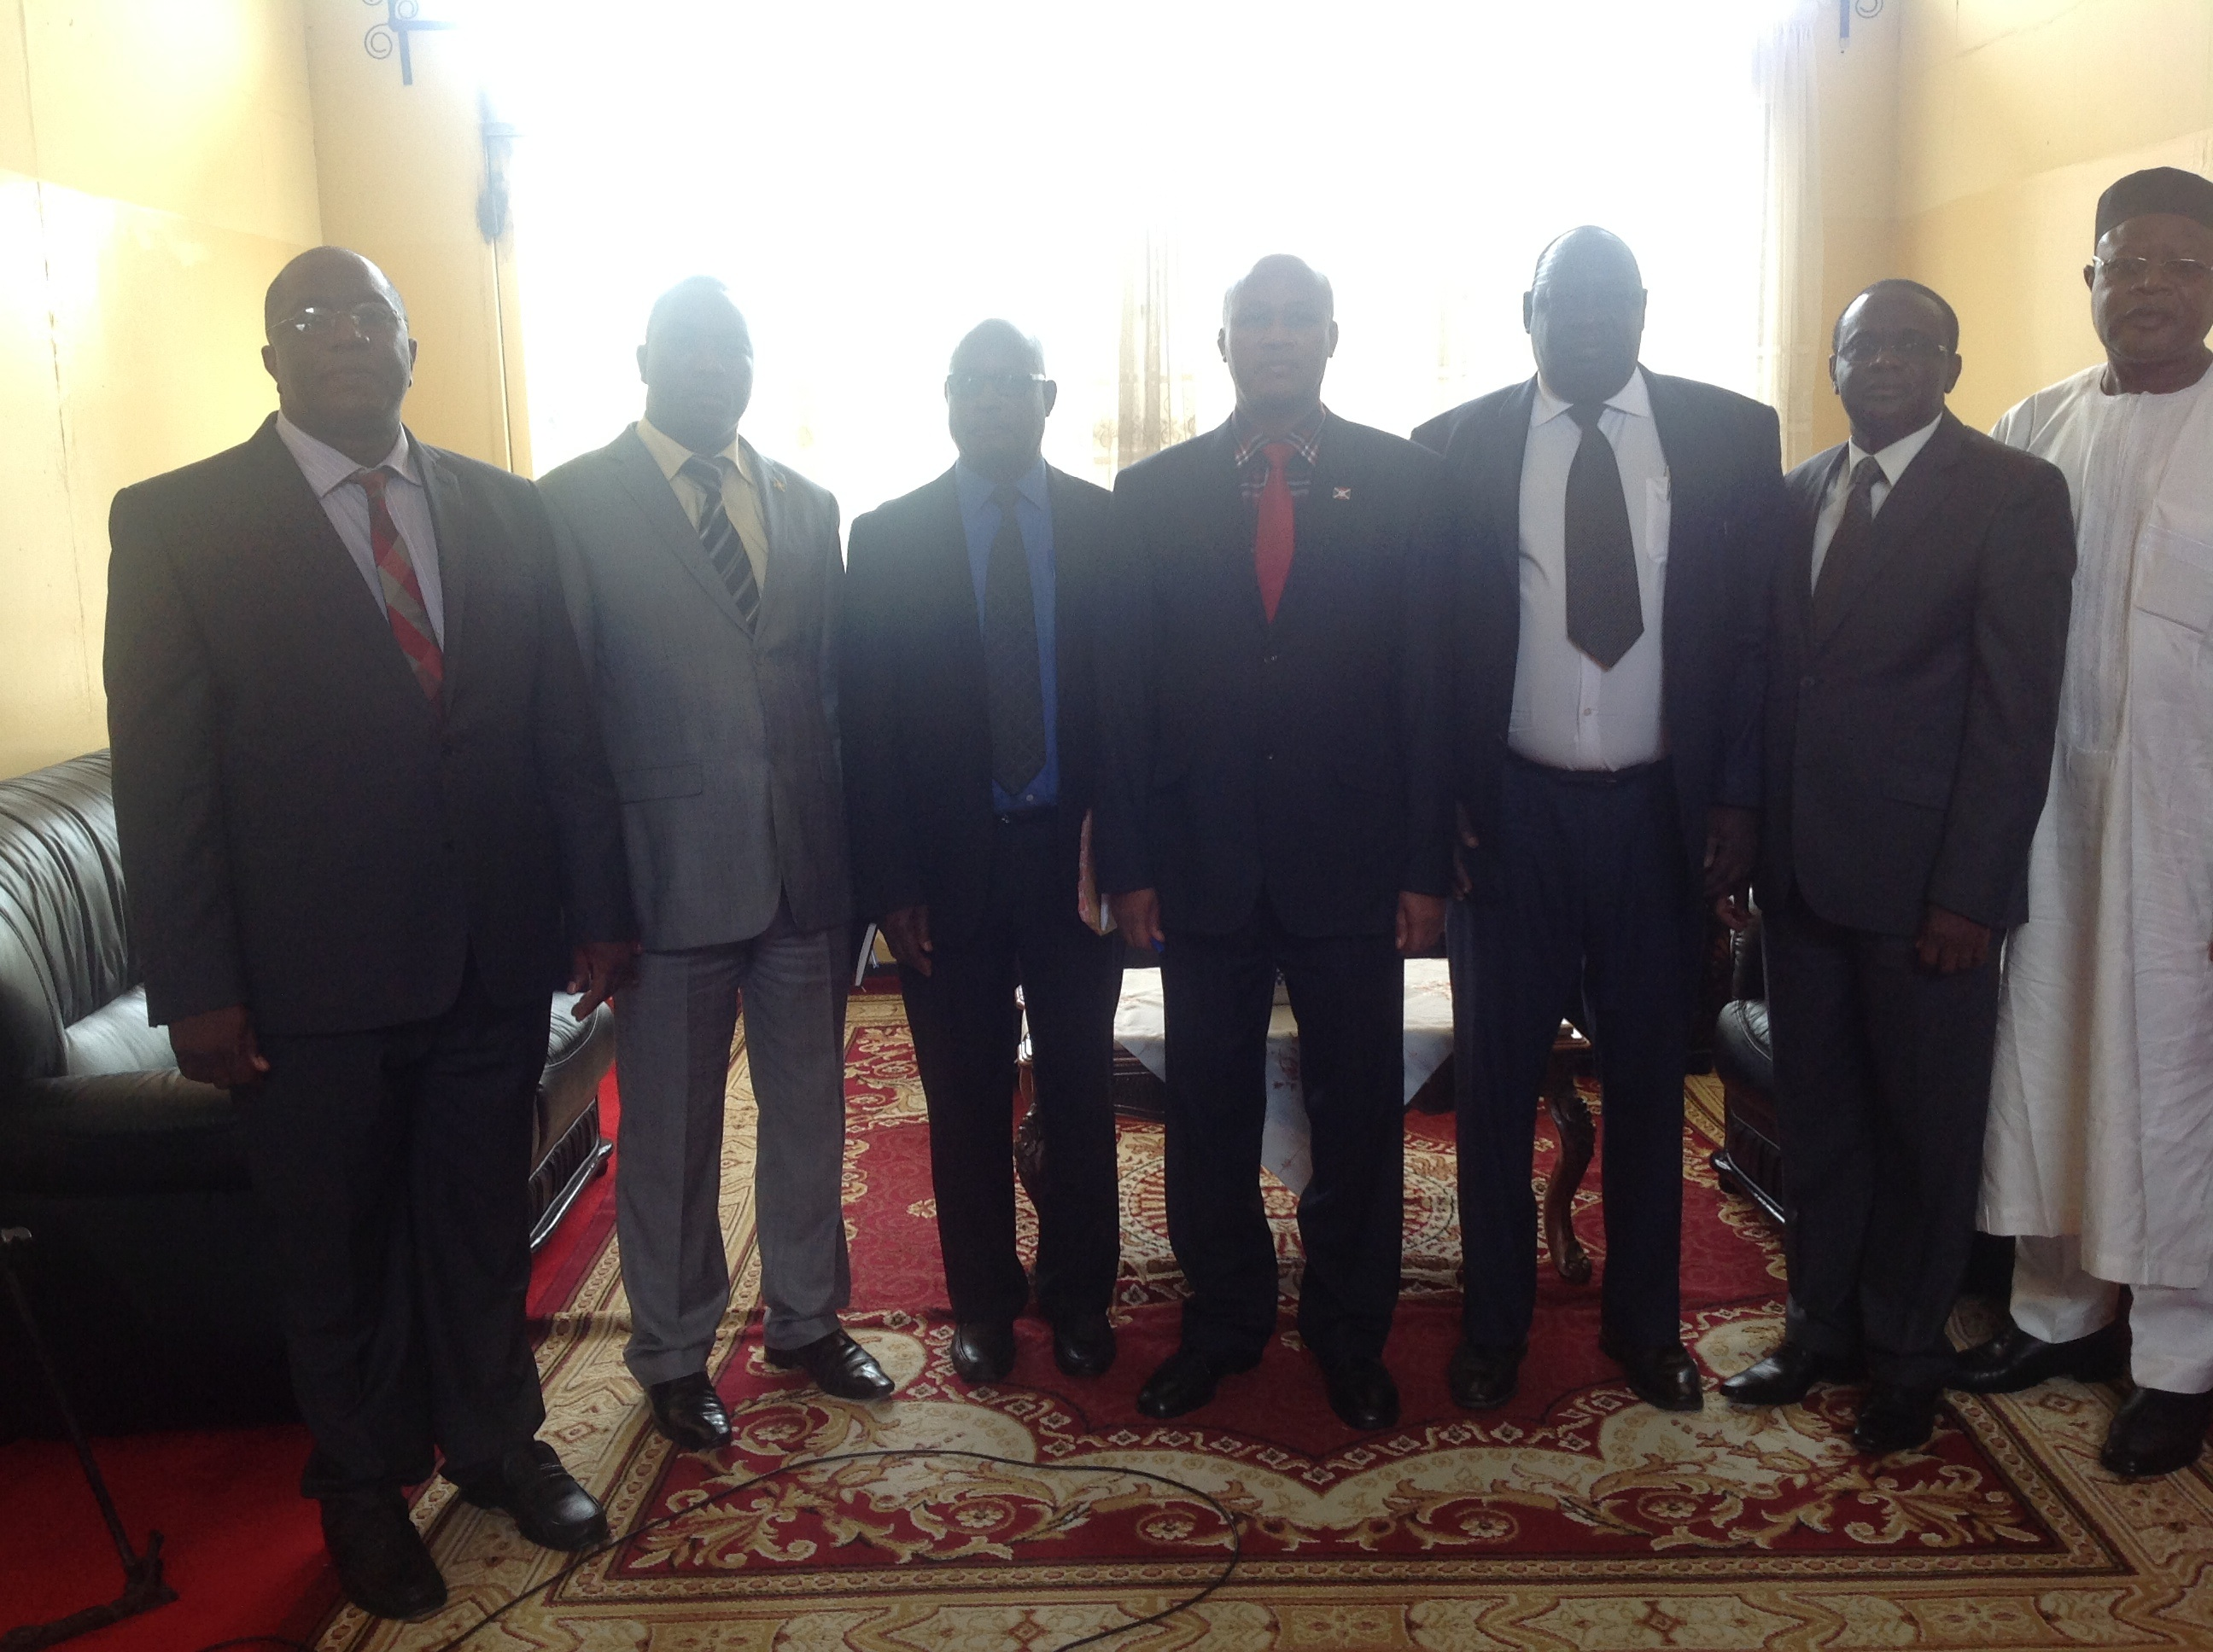
Photo1: Members of the Executive Committee with the 1st Vice President of the Republic of Burundi, Mr. Prosper Bazombanza (middle)
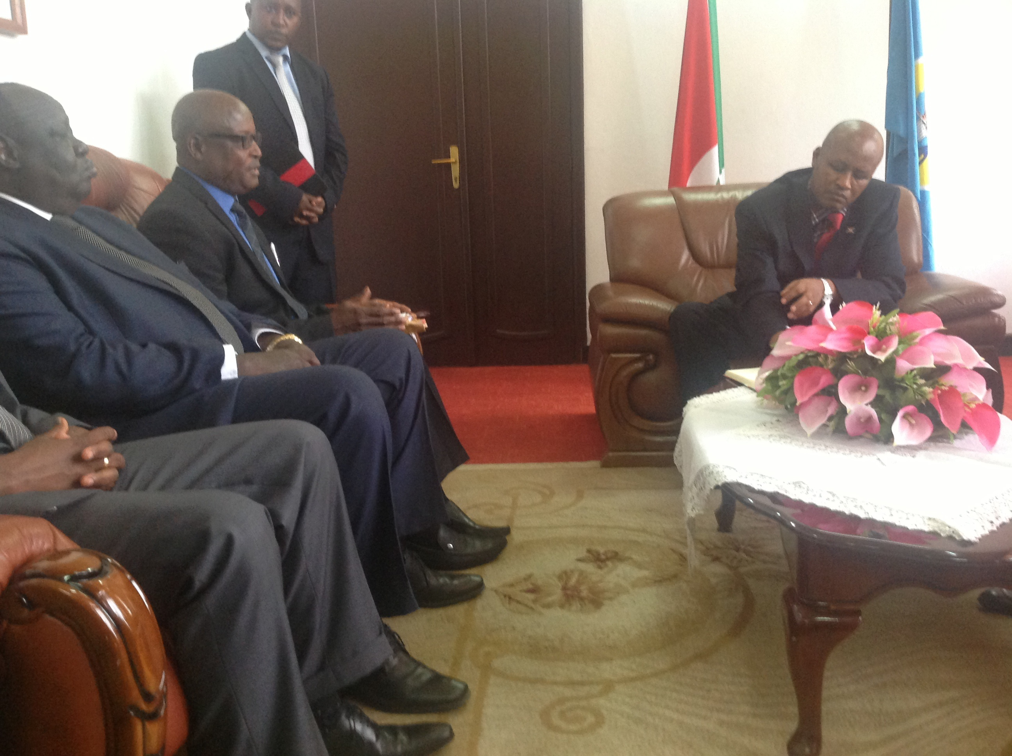
Photo2: AAACA President, Mr. Charles Ayamdoo briefing the 1st Vice President on the Association.
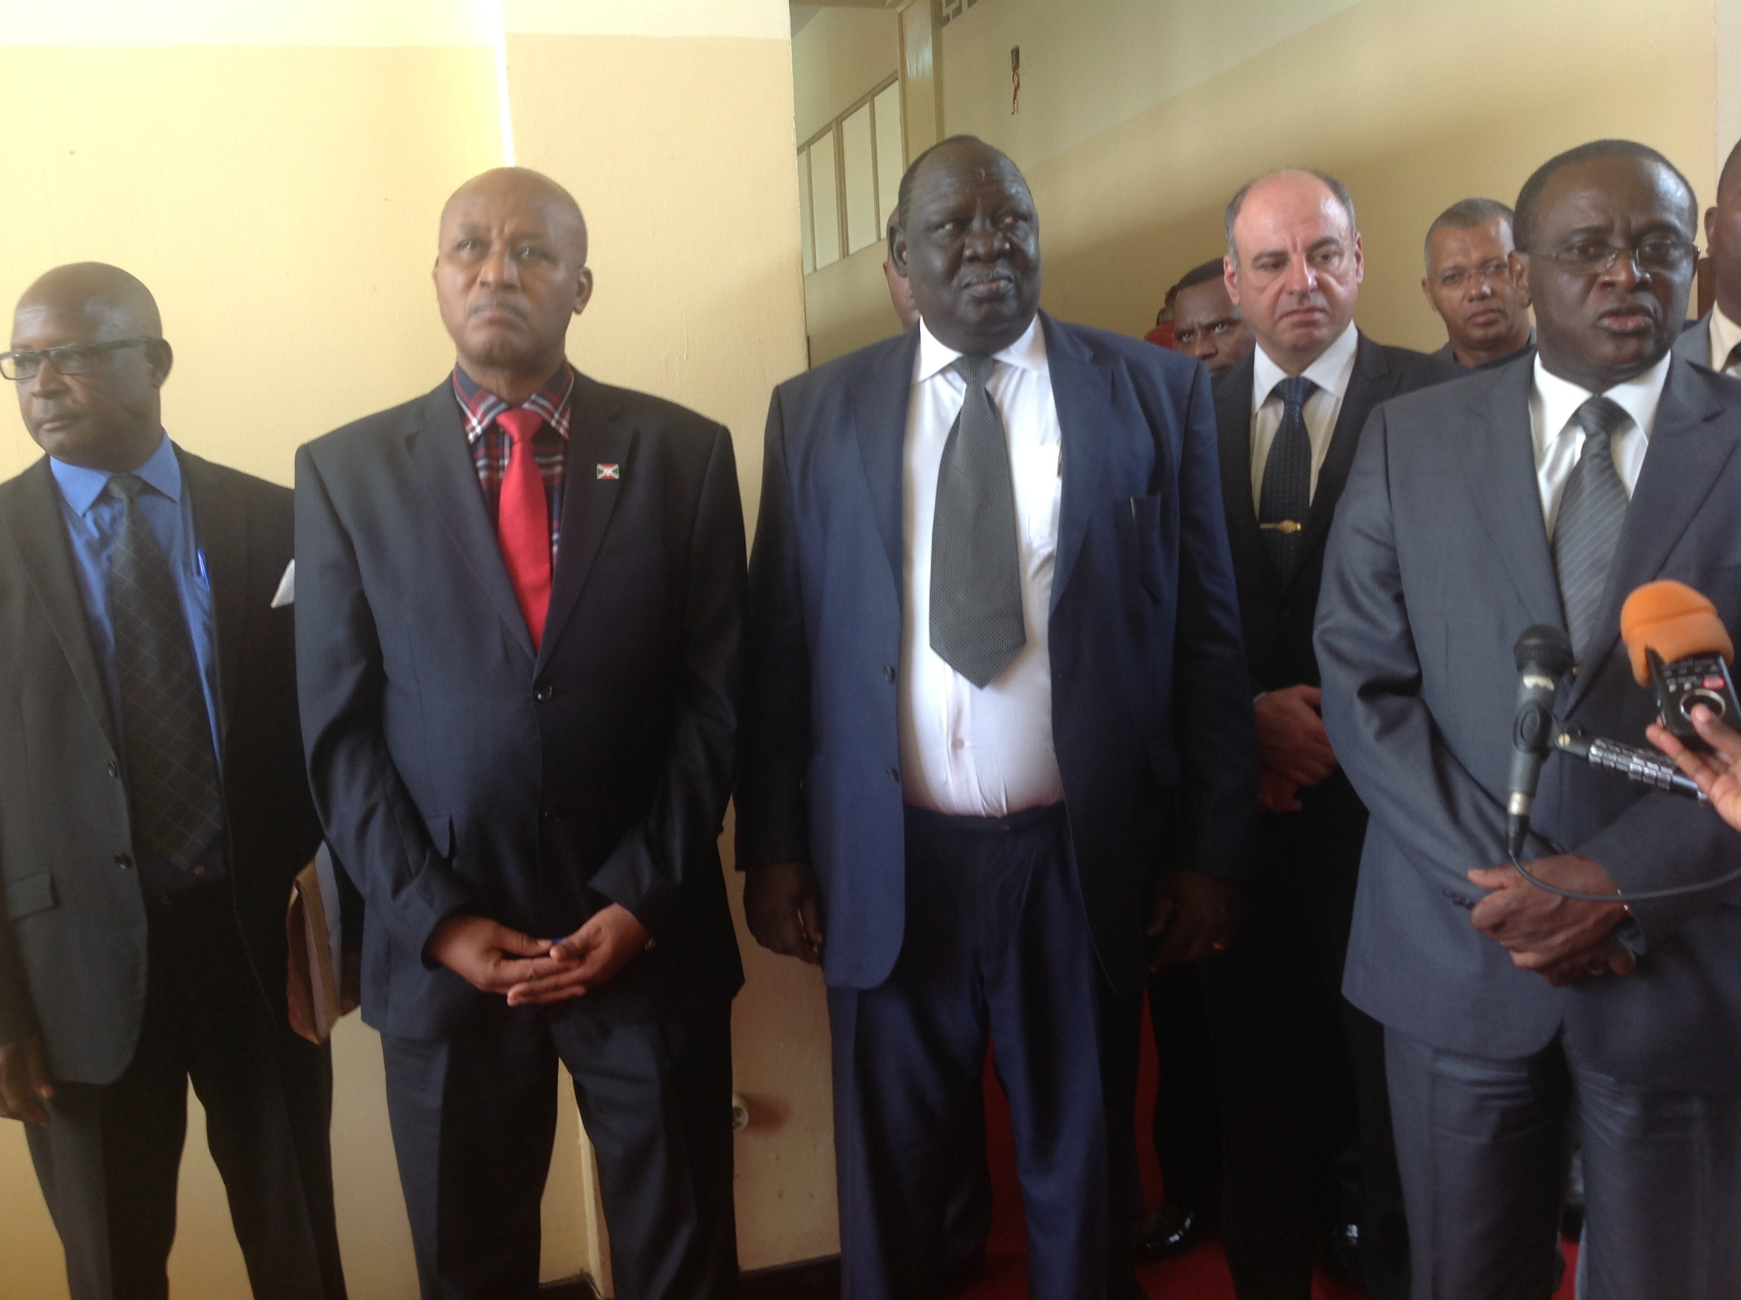
Photo3: 2nd Vice President (AAACA) being interviewed during a press conference shortly after the meeting with the 1st Vice president of the Republic of Burundi

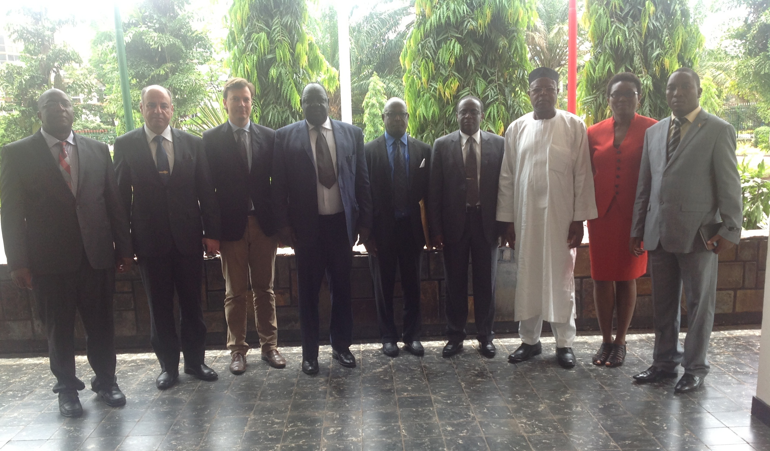
Photo4: Members of the Executive Committee shortly after the Meeting with the 1st Vice Presidentof the Republic of Burundi. Also in the photo are the UNODC Representative and the consultant recruited by UNODC to support the meeting.

Statute of the Association of Anti-Corruption Authorities in Africa (AAACA), Article 6.
Photo credits: Mr. George Bamugemereire.

